Wednesday, November 13th
1pm-1:45 General Session / Opening Ceremonies
2pm=2:45 Session Block 1
2:45-3pm 15 Minute Break
3pm-3:45 Session Block 2
4pm-4:45 Session Block 3

Thursday, November 14th
7:30-8:30 Breakfast
8:45-9:30 Session Block 4
9:45-10:30 Session Block 5
10:30-11am 30 Minute Break
11am-11:45 General Session / NASFAA Update
12pm-1:15 Lunch
1:30-2:15 Session Block 6
2:30-3:15 Session Block 7
3:15-3:45 30 Minute Break
3:45-4:30 General Session / Business Meeting
4:30-6:30 Reception

Friday, November 15th
7:30-8:30 Breakfast
8:45-9:30 Session Block 8
9:45-10am General Session / Federal Update
10:15-11am General Session / Closing Ceremonies

See Session Titles and Descriptions on Next Page

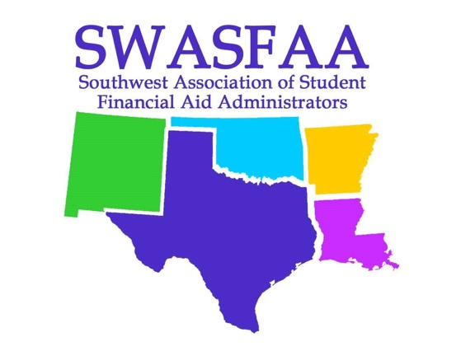

Session Descriptions

What the heck is Gazpacho? The hidden challenges of First-Generation Professionals
What happens when first generation college students enter the workforce? They become first generation professionals who often struggle to successfully navigate the work world without the necessary social or experiential skills. How do we recognize their struggles and help build a bridge across the class divide?
Paula Luff, NASFAA National Chair

"Who Me!?!" Developing a Leadership Culture with Your Team
Leadership
Lou Murray

Protect Yourself from Identity Theft
Familiarize yourself with the common forms of identity theft, take proper actions if you are a
victim and learn how you can protect yourself.
Christie Smith

It Depends
How many times to we as FAA's say the words...."it Depends" How do we as FAA's answer this question?
Denise Welch

Undetected Bias - How Well Do You Know Yourself?
As administrators of Financial Aid, we have to make hard decisions every day. Even if we try our hardest to put aside personal opinions and feelings, there are some times when they can creep up and you won't even know it. Come learn how to detect your hidden bias and some tips on how to overcome them.
Professional Development
Melanie Rinehart

How are Students really managing finances? Results from a Multiyear Behavioral Assessment
Loans, Financial Literacy
Nick Martinez

Meeting Students where they are GenZ and Beyond
This session is a very interactive session that
covers multiple generations of students that are on campus right now - GenX, Millennials, GenZ, and
even Baby Boomers. We use video, polling, and a mid-session break out to discuss best practices of
reaching students through various means of communication.
Rob Smith

Students Can't Complete if They Don't Start
Five years ago, Houston Community College’s financial aid department was facing long wait times, high call-drop rates, delayed awards, and escalated complaints. Through data-informed practices, optimized process, revamped communications, basic-needs insecurities programming, and social media, the department implemented innovative initiatives to create a student experience that aligns with guided-pathway efforts.
Jo Ellen Soucier

Financial Aid & Recruitment; a Mach Made in Enrollment Paradise
Set the scene! A student has been accepted to their top 3 school choices. In their eyes, the
schools are equal in program strength and location. How will the student decide where to
spend the next four years? What's the deciding factor for most families? One word, MONEY! In
this session, we'll discuss the role financial aid plays in the decision-making process and how to
help recruitment "seal the deal".
Kayla Lopez

NASFAA Townhall
Justin Draeger

Federal Reporting and Operational Calendar
This presentation will cover the importance of developing an operational calendar to help financial aid administrators meet deadlines related to Title IV requirements.
Amy Cable

The Economics of Financial Aid
Sandy Baum will lead a discussion of some of the most pressing enrollment and financing issues facing institutions today. She will use economic concepts and reasoning to shed light on tuition discounting, the structure of need analysis, and college access and affordability. She will address the issue of student debt and analyze some of the policy proposals currently getting attention through an economic lens.
Dr. Sandy Baum

Bridging the Informational Divide: “Speaking Student”, Forging Connections, and Creating Engagement Opportunities
This session will explore strategies to educate and engage students regarding the financial aid process and foster future healthy financial choices. “Speaking student”, forging community connections, and engagement will serve as our focus as we provide strategies to better educate and empower students. We will examine the informational divide between the financial aid process and the various audiences and demographics we serve. Anecdotal evidence, individual responses, and quantitative research conducted in our community will highlight the need and effectiveness of these strategies.
Darian Grey, Makenzee Spruiell

There will also be three sessions by Federal Student Aid Training Officer, Kevin Campbell.

